Title text, centered, sentence case, Arial Bold 13 pt, maximum 2 lines, single spaced
A. Author^{a,*}, B. Author^{a,b}, C. Author^{c}
ª Institution, Address, Town, Country
^{b} Institution, Address, Town, Country
^{c} Institution, Address, Town, Country
*e-mail: a.author@univ.pt

This is the body of the abstract. Do not delete the blank line above this one.
The authors names should be listed with first name(s) initial(s) followed by surnames (Times New Roman 11 pt). The presenting author name must be underlined. The affiliations must be referred by superscript letters and written in Times New Roman Italic 9 pt. An e-mail address should be provided for the corresponding author, marked with a superscripted star.
The abstract must be written in English, Times New Roman, 10 pt, single spaced, justified paragraphs, with maximum 1 page for both oral and poster presentations. Do not use paragraph indents or tabs. You can use the word processing styles (named abstract_xxxx) saved in this template. Do not touch header or footer.
Abstracts must be submitted via your participant area in the conference website. The file should be saved as follows: a.author_oral.docx. or a.author_poster.docx
In-line references should be cited in this manner.¹ In-line citations to Figures or Schemes should be done in this way (Scheme or Figure 1).
After the conference, all abstracts will be compiled and published in a Book of Abstracts that can be downloaded from this website.
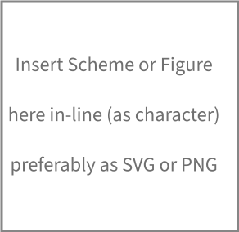
Scheme or Figure 1: Legend here
Do not change any line spacing, paragraph and character formatting in this template. Take care not to change or delete the paragraph marks after each section of this template. References should follow the ACS style.
Acknowledgments
Acknowledgments and references are written in Times New Roman 9 pt.
References
(1) Author1, A.B.; Author2, C.D. Abbrev. J. Name Year, Volume, page-range.

