Dependence of pulsed electric field and ultrasound pre-treatments on the destruction of Alicyclobacillus acidoterrestris spores in apple juice by hyperbaric inactivation

C. Pinto^{1*}, A. Ganjeh^{1,2}, J. Saraiva^{1#}

¹ LAQV-REQUIMTE, Department of Chemistry, University of Aveiro, 3810-193 Aveiro, Portugal
² LAQV-REQUIMTE, Department of Chemistry, Faculty of Pharmacy, University of Porto, 4050-313 Porto, Portugal

*E-mail of the presenting author: carlospinto@ua.pt
#E-mail of the corresponding author: jorgesaraiva@ua.pt

Alicyclobacillus acidoterrestris is a gram-positive, thermophilic microorganism that produces highly resistant spores that represent and atypical case of an endospore able to germinate and outgrowth in acidic food products, as it is generally accepted that most endospores are unable to germinate/outgrowth at pH levels below 4.6, with the acidity hurdle blocking the nutrient receptors of the spores¹. Indeed, this particular endospore represents a threat to the industry, as it is rather prevalent in fruit juices and concentrates and, in its vegetative form, it is able to produce guaiacol, which is responsible for the off-flavours and odours in fruit juices and concentrates contaminated with this microorganism².
Lately, high pressure processing (HPP) has been widely used for nonthermal pasteurization of foods, although, as for any pasteurization procedure (either thermal or nonthermal) it is unable to destroy bacterial spores, although, the combination of high temperatures (above 70 °C) with HPP has shown to be efficient for endospore inactivation. Nevertheless, the combination of these temperatures with HPP may also causes considerable changes to the food products (although in a lower extension compared with intense thermal processes aiming the inactivation of spores, such as sterilization)³.
This study investigated the hyperbaric inactivation (HI) of Alicyclobacillus acidoterrestris (ACB) spores in apple juice at pressures of 150, 200, and 250 MPa for up to 24 hours at ambient temperatures (18–23 °C). The impact of different pre-treatments - ultrasound (67 W, 20 kHz, 5 min, US) and pulsed electric field (30 kV, 80 μs, 1400 Hz, PEF) - on spore inactivation by HI was evaluated. Inactivation data were fitted to non-linear kinetic models, including Biphasic, Log-logistic, and Weibull models.
Without pre-treatment, HI achieved approximately 4.56 log reductions in ACB spores after 24 hours across all pressure levels, starting from an initial load of ~6 log CFU/mL, as seen in Figure 1.

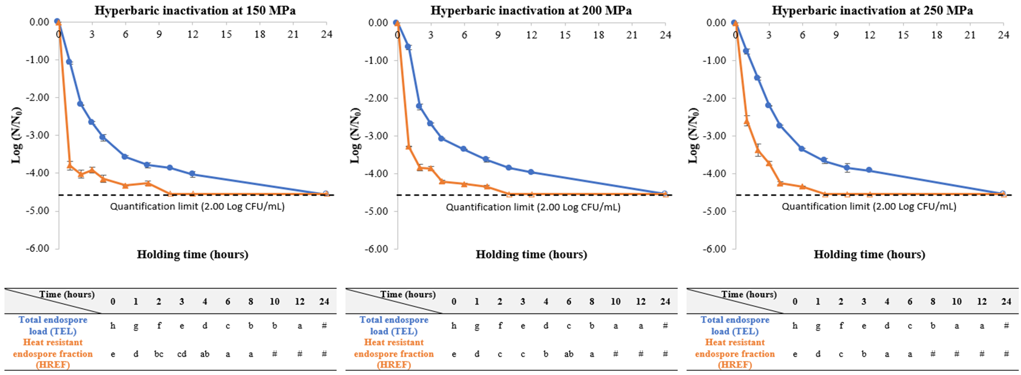
Figure 1. Total endospore load (unheated samples, TEL) and heat resistant endospore fraction (heat-treated samples at 80 ºC for 20 min, HREF) of Alicyclobacillus acidoterrestris endospores inoculated in commercial apple juice (pH 3.70) and kept under hyperbaric inactivation conditions at 150, 200 and 250 MPa up to 24h, at uncontrolled room temperatures (18-23 ºC), without any pre-activation treatment. Empty-filled symbols mean that the quantification limit (2.00 Log CFU/mL) was reached. Different lower-case letters (a-h) represent statistically significant differences (p<0.05) between the different holding times.

The pre-treatment with US did not cause neither major effect on spore inactivation nor enhanced the effectiveness of HI, with inactivation levels remaining around 4–5 log units after 24 hours. When it comes to PEF, its application prior to HI resulted in a slightly lower inactivation of about 3.5 log units after 24h. Phase contrast microscopy indicated that spores did not transition into vegetative cells during HI.
The results of this work point to the possibility of using HI to inactivate ACB spores at room temperature, without a previous pre-treatment (as neither pre-treatment enhanced the inactivation process, and PEF even slowed down the inactivation process). This methodology should be further studied in the context of ACB spores' high thermal stability and its industrial relevance.

Acknowledgements and funding

This work received support from the PT national funds (FCT/MECI, Fundação para a Ciência e Tecnologia and Ministério da Educação, Ciência e Inovação) through the project UID/50006 – Laboratório Associado para a Química Verde - Tecnologias e Processos Limpos. Thanks are also due to the FCT/MCTES for the PhD fellowships of Carlos A. Pinto (SFRH/BD/137036/2018) and Alireza Mousakhani Ganjeh (2022.12558.BD). This study was funded by the PRR – Plano de Recuperação e Resiliência and by the NextGenerationEU funds at Universidade de Aveiro, through the scope of the Agenda for Business Innovation “Plataforma de Valorização, Industrialização e Inovação comercial para o AgroAlimentar (VIIAFOOD)” (Project no. 37 AAC nº 02/C05-i01/2022 with the application C644929456-00000040).

References

- Reineke, K. & Mathys, A. Endospore inactivation by emerging technologies: a review of target structures and inactivation mechanisms. Annu. Rev. Food Sci. Technol. 11, annurev-food-032519-051632 (2020).
- Hu, X., Huang, E., Barringer, S. A. & Yousef, A. E. Factors affecting Alicyclobacillus acidoterrestris growth and guaiacol production and controlling apple juice spoilage by lauric arginate and ϵ-polylysine. LWT 119, 108883 (2020).
- Al-Ghamdi, S., Sonar, C. R., Patel, J., Albahr, Z. & Sablani, S. S. High pressure-assisted thermal sterilization of low-acid fruit and vegetable purees: microbial safety, nutrient, quality, and packaging evaluation. Food Control 114, 107233 (2020).

