Title (Bold arial 14)
First Name Last name *ª, XXXX^{b}, XXXXX^{c}
ª address, ^{b} address, ^{c} address
*email@XXXXXX

Text ARIAL 11
XXXXXXXX
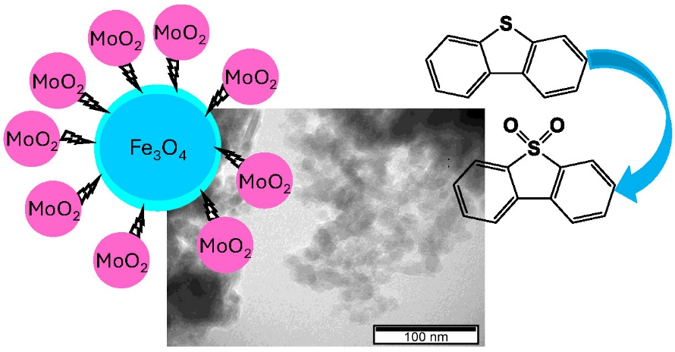
XXXXXXX
References:
[1] M.N. Hossain, H.C. Park, H.S. Choi; Catalysts 2019, 9, 229. [2] A. Rajendran, T.-C. Cui, H.-X. Fan, Z.-F. Yang, J. Feng, W.-Y. Li; J. Mater. Chem. A, 2020, 8, 2246−2285.
Acknowledgments:
This work was supported by XXXXXXXXX (ARIAL 10)

